**Starting a new project using Git**

**Excellent video on Git here** <https://www.youtube.com/watch?v=RGOj5yH7evk>

**Git commands**

|  |  |
| --- | --- |
| Command | Description |
| clone | Bring a repository that is hosted somewhere like Github into a folder on your local machine |
| add | Add files to be tracked in version control (“git add .” will include all files). |
| commit | Save your files in Git version  Git commit -m “comment message title” -m “comment message description of change”  This saves changes locally. |
| push | Upload the changes held in the commit to a remote repo like Github (Push to live)  “Git push origin master”  “Git push -u origin master” to set default upstream, then only need to use git push rather than specifying actual stream each time |
| pull | Download changes from the remote repo to your local machine (opposite of push) |
| status | List the status of files in the project to show whether committed/tracked or not. |
| init | Initialises a git repo from within the folder you are in |
| remote | Adds a repo in github from vscode  Git remote add origin <https://github.com/Staffing07/demo-git-repo.git> |

**Terminal commands**

|  |  |
| --- | --- |
| Command | Description |
| Ls | List all |
| Ls -la | List all including hidden |

Sign into github website

Create new repository

Create basic markdown file for readme.

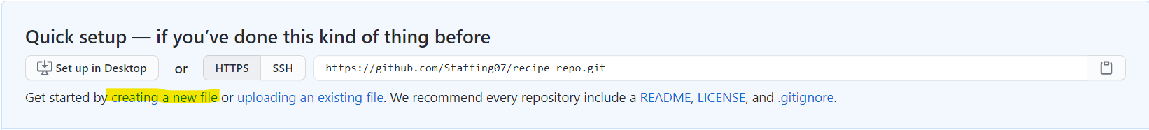

Name the readme file README.md

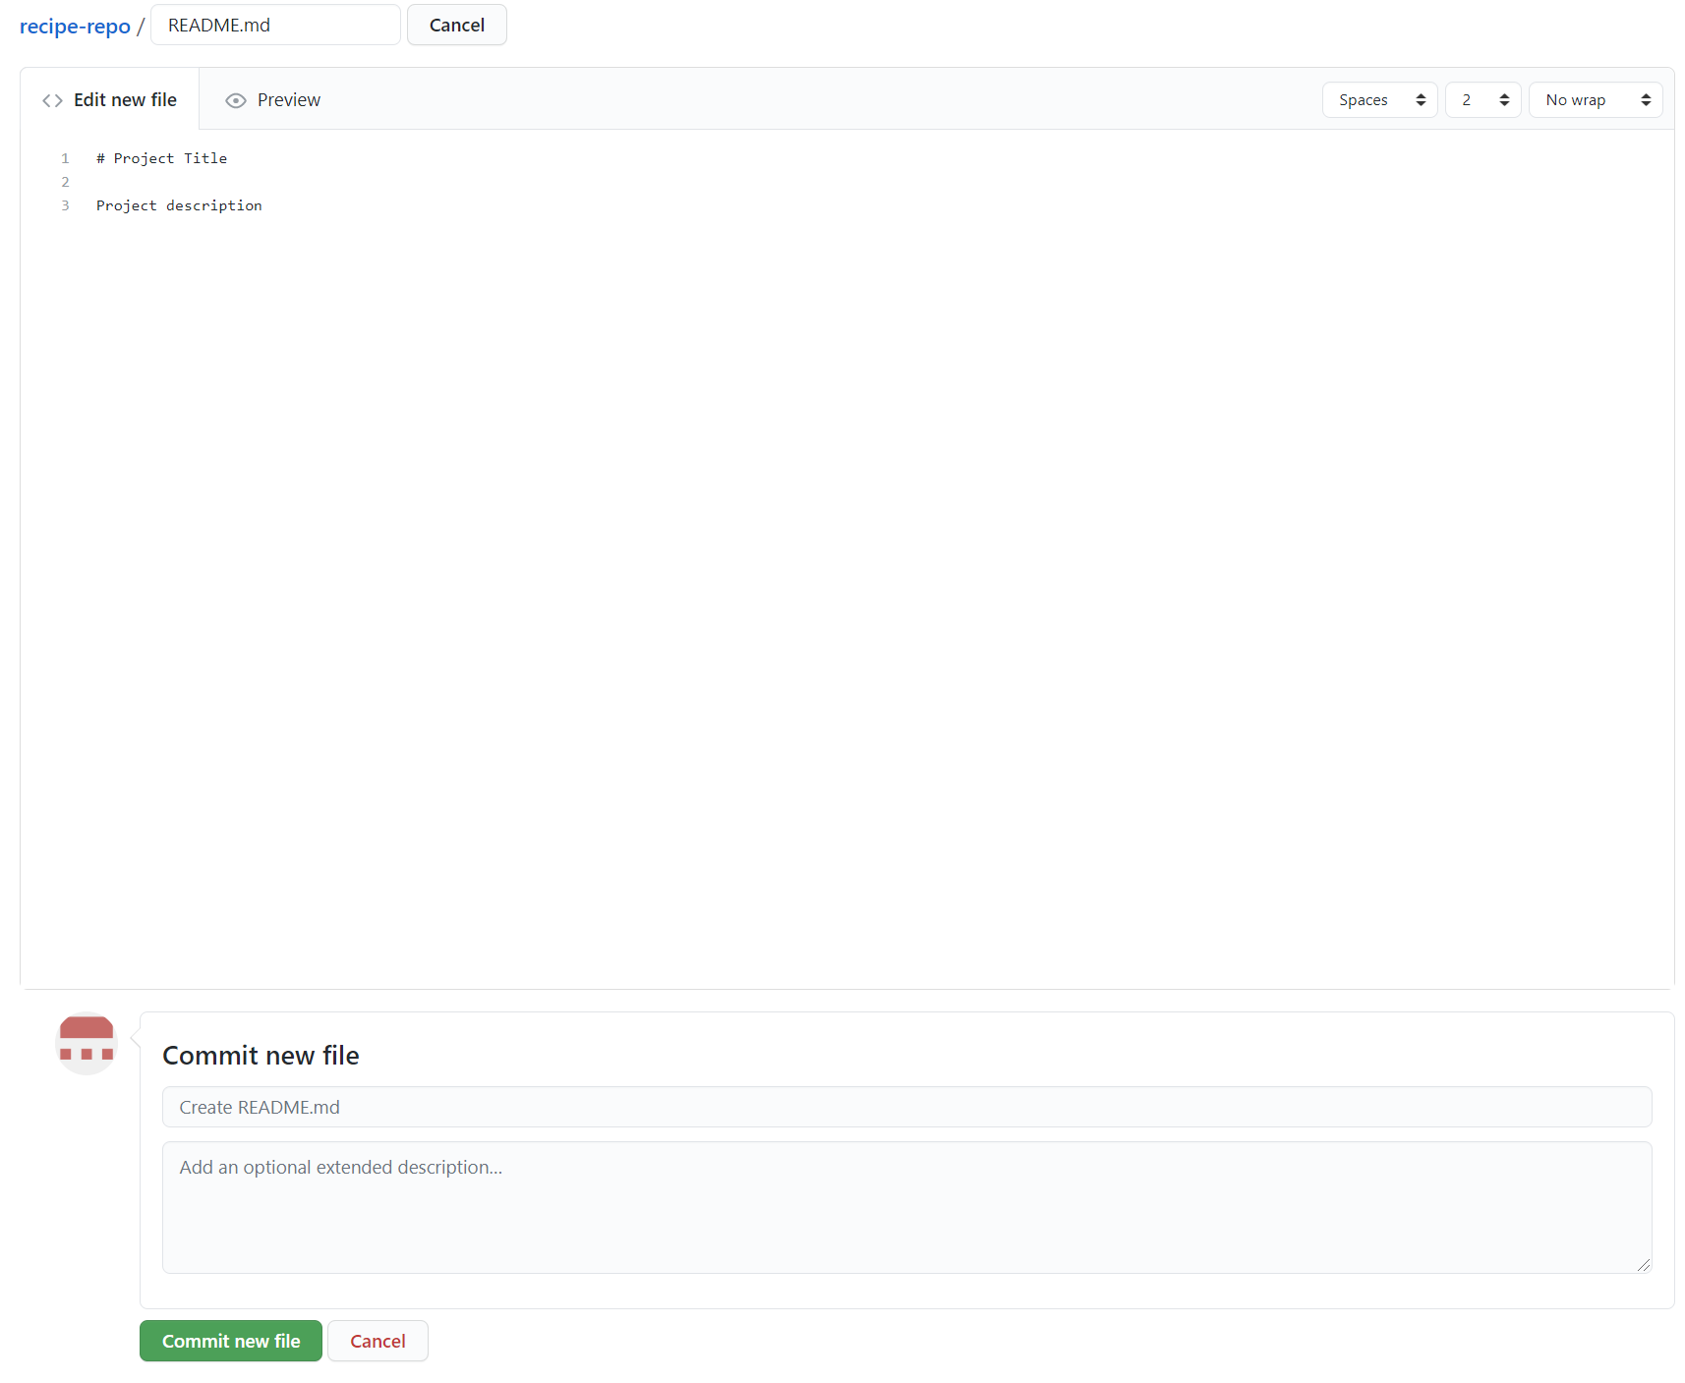

**Clone the repo from Github (use Gitbash terminal either in or out of VS Code)**

Navigate to your project folder and open it in Visual Studio.

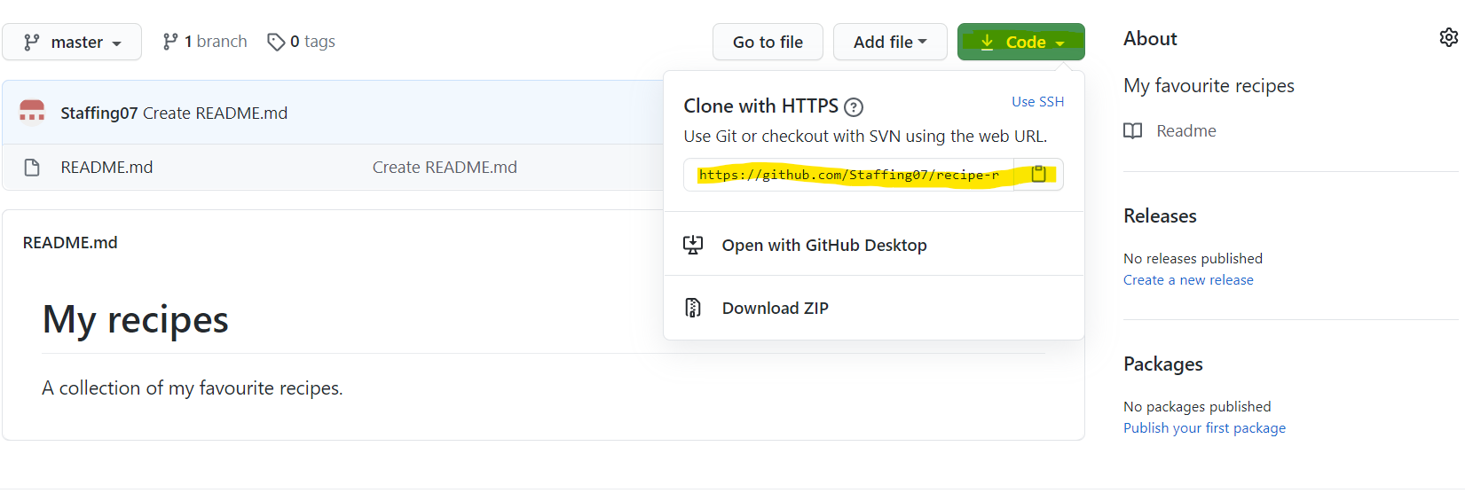

Copy the clone url.

Open a terminal in the folder you want to clone the repo to.

In the terminal type “git clone [https://github.com/Staffing07/*reponame.git*](https://github.com/Staffing07/reponame.git)”

**Setting access permissions to Github in terminal**

Need to tell Github who you are by generating a SSH key.

Enter ssh-keygen -t rsa -b 4096 -C “your github email address”

This will create 2x testkeys which you can see by entering “ls | grep testkey”

Need to upload the testkey.pub to Github.

cat testkey.pub to show the key

Copy the key text.

On the Github site go to Settings and then SSH and GPG keys

Click create new key and paste the text and give it a title.

Back in VS Code you can test the key by typing **eval “$(ssh-agent -s)”**

Then type **ssh-add -k ~/.ssh/id_rsa**

That will link your vs code project ssh key to github so you can push/pull code.

**Starting a new repo from within VS Code**

Create the files/folders you need. Don’t forget the README.md file.

From within your folder type – “git init”

Add your files using git add

Commit files to local machine svn using git commit

Now need to create the connection between the svn on your local machine and github.

Easiest way is to create an empty repository in Github.

Go to github, create empty repo and copy the address of the repo

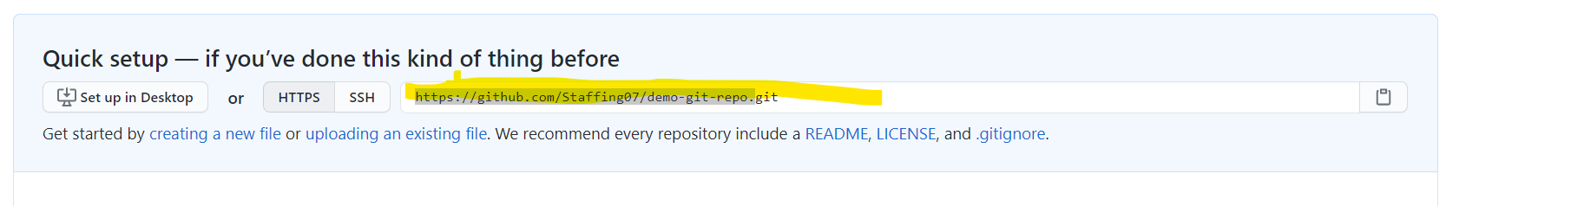

Back in vs code:

Git remote add origin <https://github.com/Staffing07/demo-git-repo.git>

This adds the remote repo.

Can check by typing git remote -v to show any remote repos currently connected to in this project.

Then type

Git push origin master

Remember you can set default repo by typing

Git push -u origin master

This sets the origin master branch as the default upstream repo. Now you only need to type git push.